UNITED STATES
SECURITIES AND EXCHANGE COMMISSION
Washington, D.C. 20549
FORM 6-K
REPORT OF FOREIGN PRIVATE ISSUER PURSUANT TO RULE 13a-16 OR 15d-16 OF THE
SECURITIES
EXCHANGE ACT OF 1934
For the Month of August 2026

Commission File Number 001-40504
Nexxen International Ltd.
(Translation of registrant’s name into English)
82 Yigal Alon Street, Tel Aviv 6789124, Israel
(Address of principal executive office)
Indicate by check mark whether the registrant files or will file annual reports under cover Form 20-F or Form 40-F.
Form 20-F ☒ Form 40-F ☐
Indicate by check mark if the registrant is submitting the Form 6-K in paper as permitted by Regulation S-T Rule 101(b)(1): ☐
Indicate by check mark if the registrant is submitting the Form 6-K in paper as permitted by Regulation S-T Rule 101(b)(7): ☐

Explanatory Note
The Annual General Meeting of Shareholders of Nexxen International Ltd. (the “Company”) will be held on September 29, 2026, at 3:30 p.m. (Israel time), at the Company’s offices at 82 Yigal Alon Street, Tel Aviv 6789124, Israel. In connection with the Annual General Meeting of Shareholders, the Company hereby furnishes the following documents as part of this Form 6-K:
Exhibit 99.1 |  |  | Notice of Annual General Meeting of Shareholders of the Company and Proxy Statement, dated August 19, 2026
Exhibit 99.2 |  |  | Form Proxy Card
Exhibit 99.3 |  |  | Form of Instruction
2

SIGNATURES
Pursuant to the requirements of the Securities Exchange Act of 1934, the registrant has duly caused this report to be signed on its behalf by the undersigned, thereunto duly authorized.
Nexxen International Ltd.
By: |  |  | /S/ Sagi Niri
Name: |  |  | Sagi Niri
Title: |  |  | Chief Financial Officer
Date: August 19, 2026
3

EXHIBIT INDEX
Exhibit  Number |  |  | Description
99.1 |  |  | Notice of Annual General Meeting of Shareholders of the Company and Proxy Statement, dated August 19, 2026
99.2 |  |  | Form Proxy Card
99.3 |  |  | Form of Instruction
4
Exhibit 99.1
NEXXEN INTERNATIONAL LTD.
NOTICE OF ANNUAL GENERAL MEETING OF SHAREHOLDERS
TO BE HELD ON SEPTEMBER 29, 2026
NOTICE IS HEREBY GIVEN that the Annual General Meeting of Shareholders (the “Meeting”) of Nexxen International Ltd. (the “Company”) will be held on September 29, 2026, at 3:30 p.m. Israel time, at the Company’s offices, located at 82 Yigal Alon Street, Tel Aviv 6789124, Israel.
AGENDA ITEMS
At the Meeting, shareholders will be asked to consider and vote upon the following proposals (each, a “Proposal” and collectively, the “Proposals”):
1. | RE-ELECTION OF FIVE DIRECTORS
To re-elect five directors of the Company to hold office until the close of the annual general meeting of shareholders in 2027, and until their respective successors are duly elected and qualified.
2. | APPOINTMENT OF INDEPENDENT AUDITORS
To approve and ratify the appointment of Kost Forer Gabbay & Kasierer, a member of Ernst & Young Global, as the Company’s independent registered public accounting firm for the year ending December 31, 2026, and until the next annual general meeting.
3. | INCREASE IN SHARE RESERVES UNDER EQUITY COMPENSATION PLANS
To approve an increase in the share reserves under the Company’s equity compensation plans.
4. | APPROVAL OF CHIEF EXECUTIVE OFFICER COMPENSATION
To approve the compensation package of the Company’s Chief Executive Officer.
In addition to considering the foregoing Proposals, shareholders will be requested to consider the Company’s audited consolidated financial statements for the fiscal year ended December 31, 2025.
The Company knows of no other matters to be submitted at the Meeting other than as specified herein. If any other business is properly brought before the Meeting, the persons named as proxies may vote in respect thereof in accordance with their best judgment.
RECORD DATE; ENTITLEMENT TO VOTE
You are entitled to vote at the Meeting if you are a shareholder of record as of the close of business on August 24, 2026 (the “Record Date”).
Holders of any of the Company’s ordinary shares, par value NIS 0.02 per share (the “Ordinary Shares”), who hold their shares through a bank, broker or other nominee that appears in the participant listing of securities depository as of the Record Date, are also entitled to vote at the Meeting.
VOTING PROCEDURES
Shareholders may vote their Ordinary Shares by:
• | Attending the Meeting in person; or
• | Completing and signing the proxy card distributed with the proxy statement.
If you hold your Ordinary Shares in “street name” through a bank, broker or other nominee (i.e., you are a beneficial owner), you must follow the voting instructions provided by your nominee. You may also be able to submit voting instructions by phone or via the Internet depending on your nominee’s procedures.
If you wish to vote at the Meeting in person, you must obtain a legal proxy from the record holder authorizing you to vote the Ordinary Shares (or to appoint a proxy to do so). Please have your control number from your voting instruction form available when submitting voting instructions.
1

RECOMMENDATION OF THE BOARD OF DIRECTORS
THE COMPANY’S BOARD OF DIRECTORS RECOMMENDS THAT SHAREHOLDERS VOTE “FOR” EACH OF THE ABOVE PROPOSALS, AS DESCRIBED IN DETAIL IN THE PROXY STATEMENT.
QUORUM AND VOTING REQUIREMENTS
The presence (in person or by proxy) of two or more shareholders holding, in the aggregate, at least twenty-five percent (25%) of the voting power of the Company shall constitute a quorum for purposes of the Meeting.
If a quorum is not present within thirty (30) minutes from the scheduled time, the Meeting will be adjourned to the following week (to the same day, time and place or to a specified day, time and place), or to such day and at such time and place as the Chairman of the Board may determine. If a quorum is not present within thirty (30) minutes from the time scheduled for the adjourned meeting, then at such adjourned meeting, the presence of one or more shareholders in person or by proxy (regardless of the voting power represented by their Ordinary Shares) shall constitute a quorum.
Each Ordinary Share entitles its holder to one vote on each Proposal. The affirmative vote of a majority of the voting power represented and voting in person or by proxy at the Meeting is required to approve each Proposal.
A special majority vote will be required for approval of the proposal in Item 4 (Chief Executive Officer Compensation). To be approved, either (i) the affirmative vote must include a majority of the Ordinary Shares voted by shareholders who are not controlling shareholders and who do not have a personal interest in the approval of the proposal (as such terms are defined in the Israel Companies Law, 5759-1999 (the “Companies Law”)), or (ii) the total number of Ordinary Shares of non-controlling shareholders and non-interested shareholders voting against such proposal must not exceed two percent (2%) of the Company’s outstanding Ordinary Shares.
ADDITIONAL INFORMATION
This Notice has been published in accordance with the requirements of the Israeli Companies Regulations (Notice of General Meeting of Shareholders and Meeting of Class of Shareholders of a Public Company), 5760-2000, as amended, and the Company’s Amended and Restated Articles of Association.
The last date for submitting a request to include a proposal pursuant to Section 66(b) of the Companies Law is August 26, 2026.
A copy of the proxy statement (which includes the full text of the proposed resolutions) and a proxy card is being distributed to shareholders and furnished to the U.S. Securities and Exchange Commission under cover of Form 6-K.
Shareholders may review the proxy statement on the “Investors” section of our Company website, https://investors.nexxen.com/financial-results/annual-reports-circulars or at our principal executive offices located at 82 Yigal Alon Street, Tel Aviv, 6789124, Israel, upon prior notice and during regular business hours and upon prior notice (telephone number: +972-3-545-3900) until the date of the Meeting.
VOTING DEADLINE
Whether or not you plan to attend the Meeting, it is important that your Ordinary Shares be represented and voted. After reviewing this Notice and the accompanying proxy statement, please sign, date, and return your proxy card in the enclosed envelope or vote by telephone or over the Internet in accordance with the instructions on your proxy card.
If voting by mail, the proxy card must be received on our behalf by Vote Processing, c/o Broadridge Financial Solutions, Inc., 51 Mercedes Way, Edgewood, NY 11717 (“Broadridge”) no later than 11:59 p.m. EDT on September 28, 2026, to be validly included in the tally of Ordinary Shares voted at the Meeting. Detailed proxy voting instructions will be provided both in the proxy statement and in the proxy card.
By the Order of the Board of Directors,
/s/ Christopher Stibbs
Christopher Stibbs
Chairperson of the Board of Directors
2

NEXXEN INTERNATIONAL LTD.
82 Yigal Alon Street
Tel Aviv 6789124
Israel
PROXY STATEMENT
ANNUAL GENERAL MEETING OF SHAREHOLDERS

TO BE HELD ON SEPTEMBER 29, 2026
This proxy statement (the “Proxy Statement”) is furnished to the holders of ordinary shares, par value NIS 0.02 per share (the “Ordinary Shares”), of Nexxen International Ltd. (the “Company”) in connection with the annual general meeting of shareholders of the Company to be held at the Company’s offices at 82 Yigal Alon Street, Tel Aviv 6789124, Israel, on September 29, 2026, at 3:30 p.m. Israel time, and thereafter as it may be adjourned from time to time (the “Meeting”). Unless the context otherwise requires, references in this Proxy Statement to “Nexxen”, the “Company”, “we” or “our” refer to Nexxen International Ltd.
AGENDA ITEMS
At the Meeting, shareholders will be asked to consider and vote upon the following proposals (each, a “Proposal” and collectively, the “Proposals”):
1. | RE-ELECTION OF FIVE DIRECTORS
To re-elect five directors of the Company to hold office until the close of the annual general meeting of shareholders in 2027, and until their respective successors are duly elected and qualified.
2. | APPOINTMENT OF INDEPENDENT AUDITORS
To approve and ratify the appointment of Kost Forer Gabbay & Kasierer, a member of Ernst & Young Global, as the Company’s independent registered public accounting firm for the year ending December 31, 2026, and until the next annual general meeting.
3. | INCREASE IN SHARE RESERVES UNDER EQUITY COMPENSATION PLANS
To approve an increase in the share reserves under the Company’s equity compensation plans.
4. | APPROVAL OF CHIEF EXECUTIVE OFFICER COMPENSATION
To approve the compensation package of the Company’s Chief Executive Officer.
In addition to considering the foregoing Proposals, shareholders will be requested to consider the Company’s audited consolidated financial statements for the fiscal year ended December 31, 2025.
The Company knows of no other matters to be submitted at the Meeting other than as specified herein. If any other business is properly brought before the Meeting, the persons named as proxies may vote in respect thereof in accordance with their best judgment and the recommendation of the Company’s board of directors (the “Board”).
RECORD DATE; ENTITLEMENT TO VOTE
You are entitled to vote at the Meeting if you are a shareholder of record as of the close of business on August 24, 2026 (the “Record Date”).
As of August 14, 2026, the Company had 56,951,431 issued and outstanding Ordinary Shares. Each Ordinary Share is entitled to one vote on each matter to be voted on at the Meeting. The votes of all shareholders voting on a matter are counted, and abstentions are not taken into account (other than for quorum purposes).
Proxies
All shareholders who are unable to attend the Meeting in person are requested to complete, date and sign the enclosed proxy form and return it promptly using the pre-addressed envelope provided.
3

If you hold Ordinary Shares in “street name” (that is, as a beneficial owner through a bank, broker or other nominee) the bank, broker or other nominee shall vote the Ordinary Shares in accordance with the voting instructions on your voting instruction card. Because a beneficial owner is not a shareholder of record, you cannot vote those Ordinary Shares directly at the Meeting unless you obtain a “legal proxy” from the bank, broker or nominee authorizing you to vote the Ordinary Shares in person at the Meeting.
Please follow the instructions on the proxy card or voting instruction card received from your bank, broker or nominee. You may also be able to submit voting instructions by phone or via the Internet if your voting instruction card describes such voting methods. Please be certain to have your control number from your voting instruction card available when submitting your voting instructions.
If you hold Ordinary Shares through a bank or broker, it is important that you instruct your bank or broker how to vote your shares so that your shares are counted for the Proposal.
Upon the receipt of a properly executed proxy in the form enclosed herewith, the persons named as proxies will vote the Ordinary Shares in accordance with the shareholder instructions. Subject to applicable law and the rules of the Nasdaq Stock Market, if no specific instructions are given, the Shares represented by properly executed and received proxies will be voted “FOR” all of the proposed resolutions recommended by the Board.
Quorum and Adjournment
Under the Company’s Amended and Restated Articles of Association (the “Articles”), the Meeting will be duly convened if at least two shareholders are present in person or represented by proxy, provided that they hold Ordinary Shares representing at least twenty-five percent (25%) of the Company’s voting power. If a quorum is not present within thirty (30) minutes of the time scheduled for the Meeting, the Meeting will stand adjourned to the following week (on the same day, time and place or to such other day, time and place as the Chairman of the Board may determine). If a quorum is not present within thirty (30) minutes from the time scheduled for the adjourned meeting, the presence of at least one or more shareholders in person or by proxy (regardless of the voting power represented by their Ordinary Shares) will constitute a quorum.
The Board may, at any time, cancel or adjourn the Meeting for a period of up to twenty-one (21) days from the date of the Meeting and/or to remove one or more items from the Meeting agenda.
Vote Required for Approval of Each of the Proposals
To approve each of the Proposals requires the affirmative vote of the Company’s shareholders holding at least a majority of the Ordinary Shares present, either in person or by proxy. In addition, a special majority vote is required for approval of the Proposal in Item 4. In order for this Proposal to be approved, either of the following conditions must be met: (i) the affirmative vote of the Ordinary Shares must include at least a majority of the Ordinary Shares voted by shareholders who are neither controlling shareholders nor have a personal interest in the approval of the Proposal (as each such term is defined in the Israel Companies Law, 5759-1999 (the “Companies Law”)), or (ii) the total Ordinary Shares of non-controlling shareholders and non-interested shareholders voted against such Proposal must not represent more than two percent of the outstanding Ordinary Shares.
Under the Companies Law, a “controlling shareholder” is defined as a person who can direct the company’s activities, excluding the role of a director or other office holder of the company. A shareholder is considered to have a “personal interest” if their immediate family member or spouse have a personal interest in the Proposal’s approval, or if a company that is affiliated with the shareholder has such a personal interest. An “affiliate” is defined as a company where the shareholder or their immediate family member holds a position of a director, chief executive officer, or owns five percent (5%) or more of the outstanding shares. However, if the shareholder’s interest arises solely from owning shares in Nexxen, they are not considered to have a personal interest.
According to the Israeli Companies Regulations (Reliefs for Companies with Securities Listed on Foreign Stock Exchanges), 5760-2000, shareholders voting on Item 4 are deemed to confirm that they do not have a personal interest and are not a controlling shareholder, unless notice has been provided. Any such notice must be submitted in writing to the attention of the Company’s Chief Legal Officer by 11:59 p.m. EDT on September 28, 2026, at the Company’s registered office: 82 Yigal Alon Street, Tel Aviv 6789124, Israel.
4

How To Vote
You can vote either in person at the Meeting or by proxy, whether or not you attend. Below are the methods available:
• | By Internet – Shareholders of record can submit a proxy online by visiting the website provided on the enclosed proxy card. Enter your control number located on the proxy card and follow the on-screen prompts. If your Ordinary Shares are held in “street name,” and your brokerage offers Internet voting, follow the instructions on the voting instruction form provided by your broker;
• | By telephone – Shareholders of record can vote by telephone by calling the toll-free number listed on the enclosed proxy card. Enter your control number located on the proxy card and follow the prompts. If your Ordinary Shares are held in “street name,” and if your brokerage offers telephone voting, follow the instructions provided on the enclosed voting instruction form; or
• | By mail – Shareholders of record can vote by completing, dating, signing, and returning your proxy card in the postage-paid envelope provided. Ensure your name is signed exactly as it appears on the enclosed proxy card. If you are signing in a representative capacity, indicate your name and title or capacity. If you hold Ordinary Shares in “street name,” you have the right to direct your brokerage firm, bank, or other similar organization on how to vote your Ordinary Shares, and the brokerage firm, bank or other similar organization is required to vote your Ordinary Shares in accordance with your instructions. To provide instructions to your brokerage firm, bank or other similar organization by mail, please complete, date, sign and return your voting instruction form in the postage-paid envelope provided by your brokerage firm, bank, or other similar organization.
Beneficial Owners
If your Ordinary Shares are held in a brokerage account or by a trustee or nominee, you will receive the proxy materials and voting instructions from your broker, trustee or nominee. As a beneficial owner, you have the right to direct how your shares are voted. To vote at the Meeting, you must obtain a “legal proxy” from the institution holding your shares.
Registered Shareholders
If you are a shareholder of record your shares are registered directly with our transfer agent, Computershare. You can vote by attending the Meeting or by completing, dating, signing, and returning the proxy card. To revoke a previously submitted proxy, you must send a written notice or submit a new proxy card with a later date. We will not be able to count a proxy card unless Broadridge receives it in the enclosed envelope no later than 11:59 p.m. EDT on September 28, 2026.
If you provide specific instructions (by marking a box) with regard to the Proposals, your Ordinary Shares will be voted as you instruct. If you sign and return your proxy card or voting instruction form without giving specific instructions your Ordinary Shares will be voted in favor of each Proposal in accordance with the recommendation of the Board. The persons named as proxies in the enclosed proxy card will vote in their discretion on any other matters that properly come before the Meeting, including the authority to adjourn the Meeting pursuant to the Articles.
Who Can Vote
Shareholders of record as of the close of business on August 24, 2026, are entitled to vote at the Meeting. If you hold shares through a broker, trustee or nominee, you may still vote by proxy through these entities.
Revocation of Proxies
Shareholders of record may revoke their proxy by submitting a written notice, submitting a proxy bearing a later date, or voting in person at the Meeting. Beneficial Owners desiring to revoke or modify their instructions should contact their broker or nominee.
5

Depositary Interest (“DI”) Holders
DI Holders may direct Computershare Investor Service PLC (“Computershare U.K.”) to vote the shares represented by their U.K. DIs in two ways:
1. | By CREST - Issue an instruction through the CREST electronic voting appointment service using the procedures described in the CREST manual (available from euroclear.com). CREST personal members or other CREST sponsored members, and those CREST members who have appointed a voting service provider, should refer to their CREST sponsor or voting services provider, who will be able to take the appropriate action on their behalf. For instructions made using the CREST service to be valid, the appropriate CREST message (a CREST Proxy Instruction) must be properly authenticated in accordance with the specifications of Euroclear U.K. & International Limited (“EUI”) and must contain the information required for such instructions, as described in the CREST manual. The message, regardless of whether it relates to the voting instruction or to an amendment to the instruction given to Computershare U.K, must be transmitted so as to be received by the Company’s agent (ID 3RA50) no later than 3.30 p.m. U.K. Time on September 24, 2026. The time of receipt will be taken to be the time (as determined by the timestamp applied to the CREST Proxy Instruction by the CREST applications host) from which the Company’s agent is able to retrieve the CREST Proxy Instruction by enquiry to CREST in the manner prescribed by CREST. EUI does not make available special procedures in CREST for any particular messages. Normal system timings and limitations apply to the transmission of a CREST Proxy Instruction. It is the responsibility of the CREST member to take (or to procure that the CREST sponsor or voting service provider takes) such action necessary to ensure that a CREST Proxy Instruction is transmitted by any particular time. CREST members and, where applicable, their CREST sponsors or voting service providers, are referred to those sections of the CREST Manual concerning practical limitations of the CREST system and timings. The Company may treat as invalid a CREST Proxy Instruction in the circumstances set out in Regulation 35(5)(a) of the Uncertificated Securities Regulations 2001, as amended (S.I. 2001 No. 3755).
2. | By Mail - Complete and return a Form of Instruction to Computershare U.K using the reply-paid envelope that accompanied the Form of Instruction or by posting it to Computershare Investor Services PLC, The Pavilions, Bridgwater Road, Bristol, BS99 6ZY, United Kingdom. To be effective, all Forms of Instruction must be received by Computershare U.K by 3.30 p.m. U.K. Time on September 24, 2026. Computershare PLC, as your Depositary, will then make arrangements to vote your underlying shares according to your instructions.
Shareholders of record as of the close of business on August 24, 2026, are entitled to vote at the Meeting.
Voting Results
The final voting results will be announced following the Meeting and furnished with the U.S. Securities and Exchange Commission (“SEC”) on Form 6-K.
Availability of Proxy Materials
The proxy card, Notice of Meeting, and Proxy Statement are available at our website: https://investors.nexxen.com/financial-results/annual-reports-circulars.
Reporting Requirements
As a foreign private issuer, we are subject to the reporting requirements of the Securities Exchange Act of 1934, as amended (the “Exchange Act”) applicable to foreign private issuers. Our filings are available on the SEC’s website at http://www.sec.gov.
As a foreign private issuer, we are exempt from the rules under the Exchange Act related to the furnishing and content of proxy statements. The circulation of this Notice of Meeting and Proxy Statement should not be taken as an admission that we are subject to the proxy rules under the Exchange Act.
AFTER CAREFUL CONSIDERATION, THE BOARD RECOMMENDS THAT SHAREHOLDERS VOTE “FOR” EACH OF THE PROPOSALS DESCRIBED IN THIS PROXY STATEMENT.
6

SECURITY OWNERSHIP OF
CERTAIN BENEFICIAL OWNERS AND MANAGEMENT; EXECUTIVE COMPENSATION
The following table sets forth the number of Ordinary Shares beneficially owned, directly or indirectly, by (i) each person known by us to be the owner of more than five percent (5%) of our outstanding Ordinary Shares, based on public filings or information provided by us, and (ii) all of our directors and executive officers as a group, as of August 14, 2026. Except as otherwise set forth below, the street address of the beneficial owners is c/o Nexxen International Ltd., 82 Yigal Alon Street, Tel Aviv 6789124, Israel.
Name of Beneficial Owner |  |  | Number of Ordinary Shares  Beneficially Owned(1) |  |  | Percentage of Ownership(2)
Mithaq Capital SPC(3) |  |  | 17,326,679 |  |  | 30.42%
JB Capital Partners L.P.(4) |  |  | 4,361,625 |  |  | 7.66%
News Corporation(5) |  |  | 4,262,661 |  |  | 7.48%
All executive officers and directors as a group (8 persons)(6) |  |  | 885,261 |  |  | 1.55%
(1) | Beneficial ownership is determined in accordance with SEC rules. Under SEC rules, a person is deemed to be a “beneficial” owner of a security if that person has or shares voting power or investment power, which includes the power to dispose of or to direct the disposition of such security. A person is also deemed to be a beneficial owner of any securities of which that person has a right to acquire beneficial ownership within sixty (60) days. Accordingly, Ordinary Shares subject to options currently exercisable or exercisable within sixty (60) days of the date of this table and restricted share units (“RSUs”) that are subject to vesting conditions expected to occur within sixty (60) days of the date of this table, are deemed to be beneficially owned. Except as indicated by footnote, and subject to community property laws where applicable, the persons named in the table above have sole voting and investment power with respect to all Ordinary Shares shown as beneficially owned by them.
(2) | The percentages shown are based on 56,951,431 Ordinary Shares outstanding as of August 14, 2026. Ordinary Shares subject to options or warrants currently exercisable or exercisable within sixty (60) days of the date of this table and RSUs that are subject to vesting conditions expected to occur within sixty (60) days of the date of this table, are deemed outstanding for computing the percentage of the person holding such securities but are not deemed outstanding for computing the percentage of any other person.
(3) | This information is based upon an Amendment No. 9 to Schedule 13D jointly filed by Mithaq Capital SPC (“Mithaq Capital”), Turki Saleh A. AlRajhi and Muhammad Asif Seemab with the SEC on December 29, 2025. Mithaq Capital is managed by its Board of Directors, which consists of Turki Saleh A. AlRajhi and Muhammad Asif Seemab, and the Board has exclusive authority concerning purchases, dispositions and voting of the ordinary shares. Each of Mr. AlRajhi and Mr. Seemab possesses an ownership interest in Mithaq Capital, and Mr. Seemab may share in any profits realized from Mithaq Capital’s investment in the Shares. Mithaq Capital may be deemed to beneficially own 17,326,679 Ordinary Shares and has sole voting and dispositive power with respect to such Ordinary Shares, while Mr. AlRajhi and Mr. Seemab each have shared voting and dispositive power with respect to such Ordinary Shares. The principal address of Mithaq Capital is c/o Synergy, Anas Ibn Malik Road, Al Malqa, Riyadh 13521 Saudi Arabia. Pursuant to Section 333(b) of the Companies Law, Mithaq Capital may not exercise voting rights in excess of twenty-five percent (25%) of our issued and outstanding Ordinary Shares.
(4) | This information is based upon an Amendment No. 1 to a Schedule 13G jointly filed by JB Capital Partners L.P. (“JB Capital”) and Alan W. Weber with the SEC on February 9, 2026. Each of JB Capital and Mr. Weber share voting and dispositive power with respect to 4,361,625 Ordinary Shares. The principal address of JB Capital and Mr. Weber is 5 Evans Place, Armonk New York 10504.
(5) | This information is based upon a Schedule 13G filed by News Corporation with the SEC on February 11, 2022. News Corp UK & Ireland Limited and News Preferred Holdings Inc., both wholly-owned subsidiaries of News Corporation, are the record holders of the 4,262,661 Ordinary Shares. News Corporation has sole voting and investment power with respect to such Ordinary Shares held by such subsidiaries. The principal address of News Corporation is 1211 Avenue of the Americas, New York, New York 10036.
(6) | Consists of (i) 862,439 Ordinary Shares directly or beneficially owned by the Company’s directors and executive officers and (ii) 22,882 Ordinary Shares constituting the cumulative aggregate number of Ordinary Shares underlying RSUs and PSUs which will have vested as of October 13, 2026.
7

EXECUTIVE COMPENSATION
The annual compensation earned during 2025 by our five most highly-compensated executive officers is set forth in Item 6 of our Annual Report on Form 20-F for the year ended December 31, 2025, as filed with the SEC on March 4, 2026 (the “Annual Report”), a copy of which is available on our website https://investors.nexxen.com/financial-results/annual-reports-circulars.
8

PROPOSAL NO. 1
RE-ELECTION OF FIVE DIRECTORS OF THE COMPANY TO HOLD OFFICE
UNTIL THE CLOSE OF THE
ANNUAL GENERAL MEETING OF THE COMPANY IN 2027
Our Board of Directors currently consists of six directors, of which five are non-executive directors:
• | Christopher Stibbs, Chairman of the Board and Non-executive director
• | Neil Jones, Senior Non-executive Director
• | Daniel Kerstein, Non-executive Director
• | Lisa Klinger, Non-executive Director
• | Rhys Summerton, Non-executive Director
The sixth director is Ofer Druker, the Company’s Chief Executive Officer and Executive Director.
At the Meeting, shareholders are being asked to re-elect five of our six directors – Neil Jones, Daniel Kerstein, Lisa Klinger, Rhys Summerton and Ofer Druker. Christopher Stibbs, the Chairman of the Board since 2020 and a director since 2019, has elected not to stand for re-election at the Meeting.
Following the Meeting, the Board will appoint one of the other non-executive directors to replace Mr. Stibbs as Chair of the Board.
Each of Mr. Jones, Mr. Kerstein, Ms. Klinger, and Mr. Summerton qualifies as an independent director under the corporate governance standards of the Nasdaq Stock Market. Each of Mr. Jones, Mr. Kerstein, and Ms. Klinger, the members of the Audit Committee, also qualify as an independent director under Rule 10A-3(b)(1) of the U.S. Securities Exchange Act of 1934, as amended.
Ms. Klinger has been designated as an “audit committee financial expert” in accordance with the SEC’s rules and possesses the requisite financial expertise as defined by the listing standards of Nasdaq. Additionally, each of our directors meet the qualifications and expertise required under the Companies Law, to serve as a director of a public company.
Board Committees
All members of the Audit Committee, Compensation Committee and Sustainability, Nominating and Governance Committee are non-executive directors. The following directors currently serve as Chairs of these committees:
• | Ms. Klinger, Chair of the Audit Committee.
• | Mr. Jones, Chair of the Compensation Committee.
• | Mr. Stibbs, Chair of the Sustainability, Nominating and Governance Committee; following the Meeting, the Board will appoint one of the other non-executive directors to replace Mr. Stibbs as Chair of the Sustainability, Nominating and Governance Committee.
In compliance with the Companies Law, each director has certified that they meet the statutory requirements for election as a director of a public company. They also confirmed that they have the necessary qualifications and sufficient time to perform their duties effectively, considering the size and special needs of Nexxen.
Attendance and Participation
Over the past year, all directors attended seventy-five percent (75%) or more of the Board meetings and seventy-five percent (75%) or more of the meetings of each of the Board’s committees on which they serve.
Nominees for Director
The Sustainability, Nominating and Governance Committee of our Board, which currently consists of Mr. Stibbs (Chairman), Mr. Jones, Mr. Kerstein, Ms. Klinger and Mr. Summerton, recommended that the five nominees be reelected to our Board at the Meeting. Our Board approved this recommendation. Each director who is elected at the Meeting will serve until the 2027 annual general meeting of shareholders and until his or her successor has been duly elected and qualified, or until his or her office is vacated in accordance with the Articles or the Companies Law.
9

Biographical information concerning all director nominees is set forth below:
Ofer Druker. Ofer Druker has served as our Chief Executive Officer and as a member of our Board of Directors since April 2019 following the completion of the merger with RhythmOne, a digital advertising technology company. From November 2017 to April 2019, Mr. Druker served as our Executive Chairman of the Tremor Video division and was instrumental in our successful integration of Tremor Video after its acquisition in August 2017. Previously, Mr. Druker was the founder and Chief Executive Officer of Matomy Media Group Ltd. (LSE:MTMY), a data-driven advertising company (“Matomy”) until April 2017, having built Matomy from its inception in 2007 into a digital media company. Mr. Druker was responsible for leading and integrating Matomy’s most important strategic transactions, including the acquisitions of Team Internet, Media Whiz, Mobfox and Optimatic.
Neil Jones. Neil Jones has served as a member of our Board of Directors since 2014. Mr. Jones spent most of his executive career in the media sector leading the Finance and M&A functions of UK listed and private equity backed businesses. He was Corporate Development Director of Inizio Group Limited, the international life science services company created from the merger of UDG Healthcare plc and Huntsworth plc (“Huntsworth”) from August 2021 until July 2025. Prior to that, he was Chief Operating Officer and Chief Financial Officer at Huntsworth from February 2016. He joined Huntsworth from ITE Group plc, the international exhibitions group, where he held the position of Chief Financial Officer from 2008 to 2016. Between 2003 and 2008, Mr. Jones was Chief Financial Officer at Tarsus Group plc, an international media company. Mr. Jones has a B.A. in Economics from the University of Manchester and completed his ACA in July 1990 with PricewaterhouseCoopers.
Daniel Kerstein. Daniel Kerstein has served as a member of our Board of Directors since December 2023. Currently, Mr. Kerstein holds the position of Managing Director, M&A, Head of Structuring Solutions and Shareholder Advisory at TD Securities. From 2011 through 2023, Mr. Kerstein held the position of Managing Director, M&A and Global Head of Activist Defense and ESG Advisory at Barclays, where he managed a global team of bankers focused on activist-shareholder defense and ESG advisory. From 2007 through 2011, Mr. Kerstein held the position of Managing Director, Global Finance at Barclays and Lehman Brothers where he led a team of structuring experts, lawyers and accountants, applying accounting, tax, regulatory and general financial expertise to address changing market and regulatory environments to create innovative financial products and strategic alternatives focused on maximizing corporate and shareholder value and improving company returns. Mr. Kerstein joined Lehman Brothers in 2003 from Merrill Lynch. From 1997 through 2003, Mr. Kerstein held the position Vice President, Corporate Finance Investment Banking at Merrill Lynch. Mr. Kerstein holds a B.A. from CUNY, Queens College and a J.D. from Harvard Law School.
Lisa Klinger. Lisa Klinger has served as a member of our Board of Directors and Audit Committee Chair since April 2021. Ms. Klinger has over 30 years of experience in international finance and capital markets. She has held the role of Chief Financial Officer and other senior finance positions at many leading consumer-facing brands such as Limited Brands, Michael’s Stores, The Fresh Market, Vince Holdings and Peloton Interactive. She has also served on the Board of Directors and as Audit Committee Chair of Emerald Holdings, Inc., a leading U.S. business-to-business platform producer of trade shows, events, conferences, marketing, and B2B software solutions, from 2018 to 2026 and also served as Chair of the Board of Directors and a member of both the Audit Committee and Compensation Committee of The Container Store Group, Inc., the leading specialty retailer of storage, organization products, custom closets and in-home services in North America, from 2021 to 2025. Ms. Klinger also served on the Board of Directors and Audit Committee of Party City Holdco, Inc., a vertically integrated party goods supplier and retailer from 2015 to 2021. Ms. Klinger holds a B.S.B.A. in Finance from Bowling Green State University.
Rhys Summerton. Rhys Summerton has served as a member of our Board of Directors since December 2023. Mr. Summerton is the founder and an investor at Milkwood Capital, a long-term, value-oriented global investment company based in the UK. Since founding Milkwood Capital in 2014, he has driven value realization across a range of investments through disciplined capital allocation and strategic decision-making. Before founding Milkwood Capital, Mr. Summerton was Managing Director and Global Head of Emerging Market Equity Research at Citigroup, where he led the firm’s top-ranked research franchise. Prior to that, he was a telecommunications and media analyst at Citigroup and Cazenove. A Chartered Accountant, Mr. Summerton began his career with Ernst & Young.
10

Proposal
At the Meeting, it is proposed that the following resolutions be adopted:
RESOLVED, that Ofer Druker be reelected to the Board of Directors of Nexxen until the close of the annual general meeting of shareholders in 2027 and until his successor has been duly elected and qualified, or until his office is vacated in accordance with the Articles or the Companies Law.
FURTHER RESOLVED, that Neil Jones be reelected to the Board of Directors of Nexxen until the close of the annual general meeting of shareholders in 2027 and until his successor has been duly elected and qualified, or until his office is vacated in accordance with the Articles or the Companies Law.
FURTHER RESOLVED, that Daniel Kerstein be reelected to the Board of Directors of Nexxen until the close of the annual general meeting of shareholders in 2027 and until his successor has been duly elected and qualified, or until his office is vacated in accordance with the Articles or the Companies Law.
FURTHER RESOLVED, that Lisa Klinger be reelected to the Board of Directors of Nexxen until the close of the annual general meeting of shareholders in 2027 and until her successor has been duly elected and qualified, or until her office is vacated in accordance with the Articles or the Companies Law.
FURTHER RESOLVED, that Rhys Summerton be reelected to the Board of Directors of Nexxen until the close of the annual general meeting of shareholders in 2027 and until his successor has been duly elected and qualified, or until his office is vacated in accordance with the Articles or the Companies Law.
Vote Required
See “Vote Required for Approval of Each of the Proposals” above.
The Board recommends shareholders vote “FOR” the re-election of each of the five directors until the close of the annual general meeting of shareholders and until his or her successor has been duly elected and qualified, or until his or her office is vacated in accordance with the Articles or the Companies Law.
11

PROPOSAL NO. 2
APPROVAL AND RATIFICATION OF THE APPOINTMENT OF KOST FORER
GABBAY & KASIERER, A MEMBER OF ERNST & YOUNG GLOBAL, AS THE
COMPANY’S INDEPENDENT REGISTERED PUBLIC ACCOUNTING FIRM
FOR THE YEAR ENDING DECEMBER 31, 2026, AND UNTIL THE NEXT
ANNUAL GENERAL MEETING
Under the Companies Law and our Articles, the shareholders of our Company are authorized to appoint the Company’s independent registered public accounting firm. Our Articles further provide that the Board (or a committee authorized by the Board) is responsible for determining the independent auditor’s remuneration. Additionally, the approval by the Audit Committee of the Board (the “Audit Committee”) of the independent auditor’s re-appointment and remuneration is required under the corporate governance rules of the Nasdaq Stock Market.
Following review and consultation, the Audit Committee concluded to recommend to the Board that the Company replace Somekh Chaikin, Member Firm of KPMG International (“KPMG”), with Kost Forer Gabbay & Kasierer, a member of Ernst & Young Global (“EY”), as the Company’s independent registered public accounting firm for the fiscal year ending December 31, 2026, and approve the engagement of EY as the Company’s independent public accounting firm. The Board subsequently accepted the recommendation of the Audit Committee and approved the engagement of EY as the Company’s independent registered public accounting firm for the fiscal year ending December 31, 2026, contingent and effective upon the approval of such engagement by the Company’s shareholders at the Meeting.
The reports of KPMG on the Company’s financial statements for the fiscal years ended December 31, 2025, 2024 and 2023 did not contain an adverse opinion or a disclaimer of opinion and were not qualified or modified as to uncertainty, audit scope or accounting principles. In connection with the audits of the Company’s financial statements for each of the fiscal years ended December 31, 2025, 2024 and 2023, and during the subsequent interim period through the date of this Proxy Statement, there were no disagreements with KPMG on any matters of accounting principles or practices, financial statement disclosure or auditing scope and procedures which, if not resolved to the satisfaction of KPMG, would have caused KPMG to make reference to the matter in their reports on the Company’s financial statements; and there were no reportable events as the term is described in Item 16F(a)(1)(v) of Form 20-F.
The Company delivered a copy of the disclosure in this Proxy Statement to KPMG and requested that a letter addressed to the SEC stating whether or not it agrees with the statements made in response to this disclosure and, if not, stating the respects in which it does not agree. KPMG responded with a letter dated July 31, 2026, a copy of which was furnished as Exhibit 99.1 to the Company’s Form 6-K, filed with the SEC on August 3, 2026, stating that KPMG agrees with the statements set forth above.
Following the recommendation by the Audit Committee and the Board, it is proposed that EY be appointed as the Company’s independent registered public accounting firm for the fiscal year ending on December 31, 2026, and until the close of the next annual general meeting, and to authorize the Board, upon recommendation of the Audit Committee, to determine the remuneration of such independent public accountants in accordance with the volume and nature of their services.
As detailed in Item 16C of our Annual Report, the following table sets out the total amount of services rendered to the Company by KPMG for the fiscal years ended December 31, 2025, and 2024, broken down by service category:
 |  |  | 2025 |  |  | 2024
 |  |  | (in thousands)
Audit Fees(1) |  |  | $741 |  |  | $816
Audit-Related Fees(2) |  |  | — |  |  | —
Tax Fees(3) |  |  | 124 |  |  | 148
All Other Fees(4) |  |  | — |  |  | —
Total |  |  | $865 |  |  | $964
(1) | “Audit fees” are the aggregate fees billed for professional services rendered for the audit of our annual financial statements or services that are normally provided by the accountant in connection with statutory and regulatory filings or engagements.
12

(2) | “Audit-related fees” are the aggregate fees billed for assurance and related services that are reasonably related to the performance of the audit or review of our financial statements and are not reported under audit fees. These fees primarily consist of accounting consultations regarding the accounting treatment of matters that occur in the regular course of business, implications of new accounting pronouncements and other accounting issues that occur from time to time.
(3) | “Tax fees” are the aggregate fees billed for professional services rendered for tax compliance, tax advice, and tax planning. These fees primarily consist of charges for professional services related to tax compliance, tax advice, and tax planning. Tax fees can encompass assistance with tax return preparation, tax audits, and consultations on tax-related matters.
(4) | “All other fees” are the aggregate fees billed for products and services provided, other than the services reported under audit fees, audit-related fees, and tax fees.
The Audit Committee, or members of that Committee, to whom approval authority has been delegated, must provide advance approval for all audit and non-audit services performed by our auditors. All services provided by the Company’s auditors are pre-approved in accordance with the Audit Committee’s policy.
Representatives from EY will attend the Meeting and may make a statement. They will also be available to respond to relevant questions raised during the Meeting. In accordance with Section 60(b) of the Companies Law, shareholders are invited to discuss our 2025 consolidated financial statements, and questions regarding the financial statements may be directed to us or to our auditors. Our Annual Report, including the 2025 audited consolidated financial statements, is available on our website at https://investors.nexxen.com/financial-results/annual-reports-circulars.
Proposal
At the Meeting, it is proposed that the following resolution be adopted:
RESOLVED, that the appointment of Kost Forer Gabbay & Kasierer, a member of Ernst & Young Global, as the Company’s independent registered public accounting firm for the year ending December 31, 2026, and until the close of the next annual general meeting, be approved. Furthermore, the Board, upon the recommendation of the Audit Committee, is authorized to determine the remuneration of EY in accordance with the volume and nature of the services rendered.
Vote Required
See “Vote Required for Approval of Each of the Proposals” above.
The Board recommends shareholders vote “FOR” Proposal No. 2
13

PROPOSAL NO. 3

APPROVAL OF INCREASE TO SHARE RESERVES OF THE COMPANY’S
EQUITY COMPENSATION PLANS
Background
Under the Nasdaq Listing Rules, a company whose shares are listed on Nasdaq is required to seek shareholder approval for the adoption or material amendment of an equity compensation plan under which employees, officers and directors may receive equity in the Company.
Currently, the Company has two (2) active equity incentive plans that allow us to grant awards to employees and other eligible service providers of the Company and its subsidiaries: the Global Share Incentive Plan (2011), as amended (the “2011 Plan”) and the Company’s 2017 Equity Incentive Plan, as amended (the “2017 Plan”, and collectively with the 2011 Plan, the “Equity Plans”).
In August 2026, the Board, following the recommendation of the Compensation Committee, amended the Equity Plans (the “Equity Plan Amendments”), subject to shareholder approval, to:
• | Increase the number of Ordinary Shares authorized for issuance under the 2011 Plan by 550,000 Ordinary Shares, bringing the total to 957,715 Ordinary Shares
• | Increase the number of Ordinary Shares authorized for issuance under the 2017 Plan by 2,300,000 Ordinary Shares bringing the total to 3,034,178 Ordinary Shares.
The Equity Plan Amendments will result in an aggregate of 3,991,893 Ordinary Shares authorized for issuance under the Equity Plans, including the additional 2,850,000 Ordinary Shares available to fund new awards proposed by the Equity Plan Amendments. The increased authorized number of Ordinary Shares under the 2017 Plan also represents the limit on the number of shares which may be issued on the exercise of options intended to qualify as incentive stock options within the meaning of Section 422 of the U.S. tax code.
In addition, the Compensation Committee and the Board approved amendments to the Equity Plans providing that, unless otherwise provided in connection with an adjustment or transaction expressly permitted under the Equity Plan, without the approval of the Company’s shareholders, the Company shall not: (i) reduce the exercise price of any outstanding stock option; (ii) cancel any outstanding stock option having an exercise price or base price that exceeds the then-current fair market value of an ordinary share in exchange for cash or another award; (iii) cancel any outstanding stock option and grant in substitution any new award having a lower exercise price or base price; or (iv) take any other action that would constitute a “repricing” under the rules of the Nasdaq Stock Market or any other applicable national securities exchange.
Importance of the Equity Plan Amendments
The Compensation Committee, the Board, and the Company’s management believe that the effective use of long-term equity incentives is essential to the Company’s ability to recruit, retain, and motivate employees, and to align executive compensation with long-term shareholder value creation.
Given the Company’s global growth and the increasing size of its workforce, as well as the need to remain competitive in attracting and retaining talent, the Compensation Committee and the Board believe it is in the best interests of the Company and its shareholders to increase the number of shares authorized under the Equity Plans.
The proposed increase in the number of Ordinary Shares authorized for issuance will provide the Company with the flexibility to grant equity incentives in amounts deemed appropriate by the Compensation Committee, the Board, and management.
If this proposal is not approved by the shareholders at the Meeting, the Board anticipates that the Company will not have enough Ordinary Shares available to fund awards that would allow the Company to compete effectively with industry peers for top talent.
If this proposal is approved, the total number of Ordinary Shares subject to outstanding awards, combined with the number of Ordinary Shares available for future awards under the Equity Plans, will equal 9.98%, which represents less than 10% of the Company’s outstanding number of Ordinary Shares plus those additional Ordinary Shares that may become issuable under outstanding or future awards under the Equity Plans based on the equity overhang data and calculation approach described below. Component (numbers) for the equity overhang calculation, along with related comments and explanation, are included below for reference.
14

Summary of the Equity Plans
The Company has the flexibility to grant a variety of equity-based awards, including options, restricted share awards, restricted share units (“RSUs”), and performance-based awards, from either the 2011 Plan or the 2017 Plan. The 2011 Plan also allows for the issuance of tax-advantaged award to eligible Israeli tax residents in compliance with Section 102 of the Israeli Income Tax Ordinance. Similarly, the 2017 Plan permits the Company to grant “incentive stock options” that qualify for favorable U.S. tax treatment under Section 422 of the U.S. Internal Revenue Code.
The 2017 Plan is set to expire on December 4, 2027, which is ten (10) years after it was approved by shareholders. After this date, no new grants may be made under the 2017 Plan; however, outstanding grants will continue to be governed by the terms of the plan. In contrast, the 2011 Plan has no expiration date. It is important to note that Ordinary Shares reserved for issuance under the 2017 Plan cannot be added to the Ordinary Share reserve of the 2011 Plan, and vice versa.
The principal features of both the 2011 Plan and the 2017 Plan are summarized under the headings “2011 Equity Incentive Plan” and “2017 Equity Incentive Plan” in Item 6.B (“Compensation”) of the Company’s Annual Report, which has been filed with the SEC, and such Equity Plan descriptions are incorporated by reference into this Proxy Statement. While these summaries provide an overview, they do not contain all details about the Equity Plans. The complete texts of the 2011 Plan and the 2017 Plan are included as Exhibit 4.2 and 4.3 to the Annual Report, and the descriptions of the Equity Plans in the Annual Report are qualified in their entirety by reference to the full text of the plans.
Share Usage
The Board continues to emphasize the importance of equity-based awards such as stock options, RSUs, and performance-vested share unit awards (“PSUs”) as a critical component of its overall compensation strategy. This approach ensures broad-based eligibility for equity incentives which is key to attracting, rewarding, and retaining talent across the organization. However, the Board is mindful of the potential dilution to existing shareholders that results from these equity grants. As a result, the Board is committed to managing the growth of the Company’s equity compensation program in a responsible and measured manner.
The Compensation Committee regularly reviews the Company’s annual and three-year average equity “burn rate,” to ensure that it is granting an appropriate number of equity incentives to meet business needs while maximizing shareholder value. Tables below show component-by-component information for the Company’s equity burn rate and equity calculations, which are key metrics for managing the equity compensation program.
Equity Overhang
This represents a common measure of potential shareholder dilution from compensation programs. Based on the information below, the Company will have an equity overhang of 9.98% if this proposal is approved to add 2,850,000 newly authorized Ordinary Shares to the Equity Plans reserves. Equity overhang is calculated as the total of (a) Ordinary Shares underlying outstanding equity awards plus Ordinary Shares available for issuance for future equity awards, divided by (b) the total number of Ordinary Shares outstanding, plus Ordinary Shares underlying outstanding option or full-value equity awards, plus Ordinary Shares available for issuance for future equity awards.
This equity overhang noted above reflects potential dilution after a substantial share buyback program in recent years. From March 1, 2022 through June 30, 2026, the Company (and its subsidiaries) repurchased 30,928,265 Ordinary Shares, or 39.9% of Ordinary Shares outstanding, reflecting a total investment of $265.3 million.
 |  |  | As of July 31, 2026
Total number of Ordinary Shares subject to outstanding options |  |  | 207,425
Total number of Ordinary Shares subject to outstanding full value awards |  |  | 4,909,295
Total number of Ordinary Shares available for grant under the 2011 Plan |  |  | 407,715
Total number of Ordinary Shares available for grant under the 2017 Plan |  |  | 734,178
Total number of RSUs and PSUs that will vest on or before April 1, 2027 |  |  | 2,514,941
Ordinary Shares Outstanding |  |  | 56,951,431
** | The Company has committed not to make any equity grants from the 2,850,000 newly authorized Ordinary Shares until the 2,514,941 RSUs and PSUs identified above have vested and converted into Ordinary Shares (or been canceled or forfeited). Because these RSUs and PSUs will convert into outstanding Ordinary Shares (or be canceled or forfeited) before any new grants are made from the expanded reserve, the 9.98% equity overhang figure above excludes these 2,514,941 shares from the numerator and includes them in the denominator.
15

The Compensation Committee and the Board believe that the proposed Equity Plan Amendments represent a reasonable level of potential equity dilution, which is aligned with the Company’s near-term talent and business needs.
Equity Burn Rate. Over the past three completed fiscal years, the Compensation Committee has responsibly managed the Company’s equity compensation program and monitored the associated potential dilution, with a 3-year average Nexxen equity burn rate that was below 25th percentile of the Company’s peer group (see Item 4 below for list of companies included in the peer group). Adjusted for share buybacks and cancellations, the Company’s net equity burn rate in the last completed fiscal year was -16.0%. On an overall basis, in each of the last three completed fiscal years, Nexxen has bought back more shares than it awarded in compensation programs.
The following table provides detailed information regarding the Company’s equity burn rate for fiscal years 2023 to 2025.
 |  |  | Fiscal Year
 |  |  | 2025 |  |  | 2024 |  |  | 2023
Total number of Ordinary Shares subject to options granted |  |  | — |  |  | — |  |  | —
Total number of Ordinary Shares subject to RSU awards granted |  |  | 2,534,753 |  |  | 2,454,034 |  |  | 176,400
Total number of Ordinary Shares subject to PSU awards granted |  |  | 246,849 |  |  | 381,447 |  |  | 71,850
Weighted-average number of Ordinary Shares outstanding (CSO) |  |  | 59,418,036 |  |  | 68,717,845 |  |  | 71,960,435
Ordinary share-based compensation cancellations |  |  | 1,431,000 |  |  | 369,000 |  |  | 614,485
Ordinary Share buybacks |  |  | 10,840,359 |  |  | 9,137,532 |  |  | 1,364,798
Burn Rate |  |  | 4.7% |  |  | 4.1% |  |  | 0.3%
Burn Rate (net of cancellations) |  |  | 2.3% |  |  | 3.6% |  |  | -0.5%
Burn Rate (net of cancellations, forfeitures and buybacks) |  |  | -16.0% |  |  | -9.7% |  |  | -2.4%
Standard equity “burn rate” is defined as the sum of stock options and full-value shares/units granted during a given period of time (e.g., the last fiscal year) divided by weighted average Ordinary Shares outstanding. In other words, it is a measure of potential dilution from equity grants during a given year. Net equity burn rate excludes cancelations and forfeitures from “shares granted” in the calculation.
As noted above, the Compensation Committee and the Board believe that the proposed Equity Plan Amendments represent a reasonable level of potential equity dilution, well below median of our peer group companies, that is aligned with Nexxen’s near-term talent and business needs. We expected the new, expanded share reserve to be sufficient for 1.0 to 1.5 years of new grants, depending on grant date share price and considering needs for annual equity grants for eligible roles throughout our Company, above target PSU payouts given our relative share price outperformance, and other prospective potential hiring needs.
Proposal
At the Meeting, it is proposed that the following resolution be adopted:
RESOLVED, that the amendments to the Equity Incentive Plans to increase the share reserves, as set forth in Item 3 of the Proxy Statement, are approved.
Vote Required
See “Vote Required for Approval of Each of the Proposals” above.
The Board recommends shareholders vote “FOR” Proposal No. 3
16

PROPOSAL NO. 4

APPROVAL OF THE COMPENSATION PACKAGE OF THE COMPANY’S
CHIEF EXECUTIVE OFFICER
Background
Shareholders are being asked to vote on a binding proposal to approve an updated compensation package for our Chief Executive Officer and Executive Director, Mr. Ofer Druker, as described below (the “CEO Compensation Package”).
Mr. Druker has served as Chief Executive Officer and as a member of the Board since April 2019, following the completion of the merger with RhythmOne, a digital advertising technology company.
Approval Requirements Under Israeli Law
Under the Companies Law, a public company must obtain approval from its compensation committee, board of directors and shareholders, in that order, before approving the terms of compensation for its chief executive officer.
Unlike the advisory “say-on-pay” votes commonly found in proxy statements for U.S. domestic public companies, this shareholder vote is binding under Israeli law. If this proposal is not approved by the requisite shareholder majority, the Company will not be authorized to grant equity awards.
Executive Compensation Philosophy and Methodology
Our executive pay program is designed and administered to balance and support the achievement of near-term operational results and long-term growth goals, with the ultimate objective of protecting and increasing shareholder value, and retaining talent viewed as important to supporting our ongoing growth and success. The principal elements of an executive’s annual total compensation are: base salary, annual bonus opportunity, and other long-term cash or equity incentive awards.
As outlined in the Company’s Remuneration Policy for Directors and Executives, the Compensation Committee and the Board believe that strong, effective leadership is critical to the Company’s long-term success. Accordingly, the Company’s executive compensation framework is designed to reflect its core compensation philosophy and to achieve the following objectives:
• | Maintain market-competitive pay programs that attract and retain top talent
• | Use incentive programs to drive performance aligned with the Company’s business strategy and drive desired behavior
• | Align compensation outcomes with multi-year business performance and success/outcomes
• | Reward executives for outperformance against established goals and plans.
• | Support sound risk management by applying multiple performance measurement periods
• | Ensure that, over time, actual pay outcomes for executives are commensurate with financial performance results and shareholder value creation, with strong on performance-based pay
Things We Do
Our executive pay program is targeted to support our business strategy and features many practices designed to promote alignment with the interests of our shareholders.
Prudent Use of Equity-based Pay 󰸅 During the last three (3) fiscal years, our equity burn rate was positioned below 25th percentile versus our peer group companies.
• | Equity burn rate is a measure of potential dilution from equity grants during a defined period of time, and can be defined as the sum of shares, stock units and stock options granted in a given period of time divided by common shares outstanding.
• | The Compensation Committee reviews our equity burn rate market benchmark data and market comparisons on a regular basis.
17

Maintain Prudent Incentive Structures Our executives may receive between 0% and 150% of their target annual cash bonus; similarly, performance-based long-term incentives may also pay out between 0% and 150% of the target amount.
• | This means incentive pay programs for our executives include caps on potential payout.
• | In addition, actual payout is based on pre-defined performance/payout curves, with threshold, target, and maximum performance goals for each metric.
Provide Reasonable, Competitive Target Pay Levels 󰸅 We intend for target total direct compensation (salary/bonus/long-term incentives) of our executives, in general, to be positioned within a competitive range of market median.
• | In line with this, the target total direct compensation for our CEO is positioned near the median relative to the CEOs of our peer group companies.
• | Actual pay outcomes may vary above or below target based on actual financial and stock price performance.
Believe in Executive Stock Ownership 󰸅 We maintain a minimum stock ownership guideline for our CEO of 6.0x his base salary, which is a robust standard relative to our peer group companies.
No Single-Trigger Vesting Acceleration 󰸅 For multiple years, all equity awards granted to our executives have included double-trigger vesting provisions in connection with a potential change in control. We do not provide single-trigger vesting acceleration, meaning a change in control alone will not accelerate vesting; a qualifying termination of employment must also occur.
Incorporate Governance “Best Practices” Our governance practices reflect several elements designed to support long-term Company performance and Board effectiveness. For example, we plan for and discuss management succession and the development of our leadership team on an ongoing basis. In addition, our Compensation Committee engages an independent compensation consultant, who attends Compensation Committee meetings and also meets separately with the Compensation Committee and individual Compensation Committee members, both with and without management present.
Shareholder Engagement Our Board, the Compensation Committee, and our management team value the input and opinions of our shareholders, and are committed to ongoing engagement with our shareholders. The Compensation Committee strives to ensure our executive compensation program supports and aligns with the interests of our long-term shareholders and adheres to our pay for performance philosophy. Engagement efforts take place throughout the year, through various venues, between our board members and/or senior management and representatives of our shareholders. The Compensation Committee discusses the feedback we receive from investors throughout our yearly engagement efforts, and also considers that feedback as part of its pay-related decision-making.
Maintain Executive Remuneration Clawback Policy We maintain a clawback policy that allows for the recovery of executive remuneration paid on the basis of financial data included in any of the prior three fiscal years that was subsequently found to be inaccurate and restated. The Compensation Committee is responsible for approving amounts to be recouped and setting terms for clawback proceedings.
CEO Compensation Review
Independent Compensation Advisor
The Compensation Committee directly engaged the services of Compensation Advisory Partners LLC (or “CAP”), a leading global provider of consulting services for compensation and related governance matters. Areas of support provided by CAP include, but are not limited to: providing advice to the Committee regarding its decisions and Nexxen pay programs, attending and providing input during Compensation Committee meetings, addressing questions when needed, providing market benchmark data for pay levels and pay practices, and supporting the Compensation Committee and Company efforts to ensure that the Company’s compensation practices, programs and related decisions were aligned with the Compensation Committee-approved Nexxen compensation philosophy and executive compensation guiding principles.
CAP reported directly to the Compensation Committee. The Compensation Committee concluded, after taking into consideration SEC and Nasdaq-designated independence factors for compensation consultants, that no conflict of interest exists that would prevent CAP from providing independent advice to the Compensation Committee. CAP will not perform other services for Nexxen without the consent of the Chair of the Compensation Committee. CAP meets with the Compensation Committee Chair and the Compensation Committee outside the presence of management on a regular basis.
18

Peer Group
The Company’s peer group is periodically reviewed and approved by the Compensation Committee with guidance from CAP and considering input from senior management. The Company’s peer group is composed of companies that:
• | operate in industries or markets similar to the Company;
• | are comparable in size, based on revenue and market capitalization; and
• | position the Company near the median of the group, in terms of size.
The peer group in effect when the CEO Compensation Package was reviewed by the Compensation Committee and CAP consisted of the following twelve (12) companies:
Cardlytics |  |  | LiveRamp |  |  | TechTarget
comScore |  |  | Magnite |  |  | Upland Software
Digital Turbine |  |  | Perion Network |  |  | Viant Technology
LivePerson |  |  | Pubmatic |  |  | QuinStreet
In its decision-making, the Compensation Committee considered target pay levels for CEOs of peer group companies as an input to its decision-making process. The Compensation Committee determined that the current CEO Compensation Package was aligned with the Company’s intended market position (i.e., was positioned near the median) relative to target total annual pay of peer group CEOs. The Compensation Committee determined that the proposed CEO Compensation Package, with no increases being proposed at this time, provides an appropriate link between actual compensation outcomes for Mr. Druker and both actual financial results for the Company and value creation outcomes for shareholders, over different time horizons.
Proposed CEO Compensation Package
No changes are being proposed for fiscal 2027 to Mr. Druker’s current compensation terms, which were last approved by shareholders in January 2026 and entitle him to the following annual compensation:
Cash Compensation
• | Base Salary: $750,000 per year.
• | Annual Cash Bonus: Target annual cash bonus of 200% of base salary ($1.5 million) with an over-achievement rate capped at 150% of the target bonus (300% base salary), effective for fiscal years 2026 and 2027. The cash bonus threshold, target, and maximum performance targets are approved on an annual basis by the Compensation Committee and the Board in accordance with the Company’s Remuneration Policy for Directors and Officers. The 2024, 2025, and 2026 performance targets were tied to the achievement of Company Revenue and Adjusted EBITDA goals.
○ | Proposed Compensation Package: The Compensation Committee and the Board recommend no change to Mr. Druker’s annual base salary and recommend extending the same level of annual cash bonus opportunity through fiscal year 2028.
Additional Time-Based and Performance-Based Award Opportunities
In 2025, Mr. Druker’s additional annual time-based and performance-based cash awards had a target grant value of $1.75 million, consisting of:
• | 25% Time-Based Cash Award; and
• | 75% Performance-Based Cash Award.
○ | Proposed Update: The Compensation Committee and the Board recommend the same annual time-based and performance-based awards for 2026 with a target grant value of $1.75 million, maintaining the same allocation of 25% Time-Based and 75% Performance-based Cash Awards, as detailed below.
19

Additional Time-Based Cash Award Opportunity
• | Time-Based Cash Award Value. $437,500.
• | Vesting Requirements. 100% vests twelve (12) months after the date the grant was approved by the Compensation Committee and the Board (i.e., August 11, 2027), subject to Mr. Druker’s continued service with the Company on the vesting date.
Additional Performance-Based Cash Award Opportunity
• | Performance-Based Cash Award Value. $1,312,500.
• | Vesting. Subject to both performance- and time-based vesting conditions with:
○ | Two performance periods: a two-year performance period weighted 41% and a one-year performance period weighted 59%. The performance goals for performance metric, including the start date for relative Total Shareholder Return (“TSR”) calculations, will align with those approved by our Board for 2026 incentive awards for the same metrics for incentives that apply across our leadership team for the same performance periods. The time-based vesting provision for the 1- and 2-year performance period tranches will be twelve (12) and twenty-four (24) months after the grant date that was approved by the Committee and the Board (i.e., August 11, 2027, and August 11, 2028), subject to Mr. Druker’s continued service with the Company on the vesting date, unless otherwise defined herein.
○ | Metrics tied to pre-defined Adjusted EBITDA and relative TSR threshold, target and maximum performance goals, with each metric weighted 50%. The Compensation Committee established metrics designed to balance absolute financial performance and relative market performance, with challenging but achievable targets. For the relative TSR component, relative TSR must be at or above the median for target payout to be achieved, and relative TSR must be at least the 25th percentile for any payout to occur.
• | Payout for the performance-based cash award, if any, will be assessed annually considering actual performance results versus the pre-defined goals and subject to both approval of related actual results and payouts by the Board and also Mr. Druker being engaged by the Company on the relevant vesting dates, unless otherwise defined herein.
Overview and General Terms
• | Grant Date. Awards will be granted on the date shareholders approve the updated CEO Compensation Package.
• | Potential Above-Target Payout. Above-target payout can be up to 1.5x target ($) value.
• | Acceleration of Vesting in Certain Events. Awards are subject to “double trigger” acceleration, meaning vesting will accelerate in full upon both: (i) a change of control and (ii) termination of employment without cause. In such event, all outstanding performance-based and time-based cash compensation awards held by the CEO at such time shall immediately vest in full, with any applicable performance conditions deemed to be achieved at target.
• | Retirement Provision. If Mr. Druker elects to leave (retire) at least two (2) years after January 1, 2025, and provides at least six (6) months prior written notice to the Board, his unvested performance-based and time-based awards will continue to vest post-retirement on their regular schedule, subject to continued compliance with post-retirement restrictive covenants and his provision of reasonable transition support, as requested.
• | Stock Ownership Guidelines. Mr. Druker is expected to maintain ownership of Company securities (or unvested performance-based and time-based cash incentive awards) valued at no less than 6.0x his annual base salary. His ownership currently exceeds this minimum expectation.
Recommendation
The Compensation Committee and the Board believe that the proposed updated CEO Compensation Package is in the best interests of the Company and its shareholders. Accordingly, they unanimously recommend that the shareholders approve the updated CEO Compensation Package.
20

Proposal
At the Meeting, it is proposed that the following resolution be adopted:
RESOLVED, that the updated CEO Compensation Package, as set forth in Item 4 of the Proxy Statement is approved.
Vote Required
See “Vote Required for Approval of Each of the Proposals” above.
The Board recommends shareholders vote “FOR” Proposal No. 4
21

SHAREHOLDER PROPOSALS FOR 2027 ANNUAL GENERAL MEETING OF SHAREHOLDERS
Under the Companies Law, shareholders who severally or jointly hold at least one percent (1%) of the Company’s outstanding voting rights are entitled to request that the Board include a proposal in a future shareholders’ meeting, provided that such proposal is appropriate for consideration by shareholders at such meeting. To be considered for inclusion in the Company’s proxy statement for the 2027 Annual General Meeting of Shareholders pursuant to the Companies Law, shareholder proposals must be submitted in writing to 82 Yigal Alon Street, Tel Aviv 6789124, Israel, Attention: Chief Legal Officer. Proposals must be received no later than ninety (90) calendar days prior to the first anniversary of the Meeting (i.e., July 1, 2027; provided that if the date of the 2027 annual general meeting of shareholders is advanced by more than thirty (30) calendar days prior to, or delayed (other than as a result of adjournment) by more than thirty (30) calendar days after, the anniversary of the Meeting, for a proposal by a shareholder to be timely it must be so delivered not later than the 7th calendar day following the day on which the Company calls and provides notice of the 2027 annual general meeting of shareholders). All proposals must comply with the requirements of the Companies Law and the Articles.
Expected Agenda for the 2027 Annual General Meeting
The Company anticipates that the agenda for the 2027 Annual General Meeting will include:
(1) | election (or re-election) of directors;
(2) | appointment of our Company’s auditors; and
(3) | presentation and discussion of the Company’s audited financial statements for the fiscal year ended December 31, 2026, and the auditors’ report for this period.
Format and Content of Shareholder Proposals
To be valid, a shareholder proposal must be submitted in English and include the following information:
1. | Name, business address, telephone number, and email address of the proposing shareholder (and, if applicable, each member of the shareholder group) and, if the proposing shareholder is not a natural person, equivalent information for the individual(s) controlling or managing such entity.
2. | The number of Ordinary Shares held by the proposing shareholder, directly or indirectly (including beneficial ownership as defined under Rule 13d-3 of the Exchange Act).
a. | If any Ordinary Shares are held indirectly, an explanation of how and by whom they are held must be included.
b. | If the proposing shareholder is not the holder of record of any such Ordinary Shares, a written statement from an authorized bank, broker, depository or other nominee, as the case may be, must confirm the number of Ordinary Shares the proposing shareholder is entitled to vote as of a date that is no more than ten (10) days prior to submission.
c. | A description of any agreements, arrangements, or understandings including derivative or swap transaction relating to the Company’s securities or the proposal itself that affect the shareholder’s economic exposure.
d. | The purpose of the proposal.
e. | The full text of the resolution proposed for shareholder consideration.
f. | A statement disclosing whether the proposing shareholder has a personal interest in the proposal and, if so, a detailed description of that interest.
g. | A declaration confirming that all required information under the Companies Law and any other applicable law has been provided.
h. | If the proposal relates to the nomination of a director to the Board, a completed questionnaire and declaration (in form reasonably requested by the Company) signed by the nominee, including details of the nominee’s identity, address, background qualifications, and consent to serve on the Board if elected.
i. | Any additional information required by the Articles or otherwise reasonably requested by the Company.
22

The Company reserves the right to publish information provided by a proposing shareholder, and the shareholder will be responsible for its accuracy. Proposals that are not timely and properly submitted or that fail to comply with applicable law or the Articles may be disregarded.
Regulatory Notice
The information in this section constitutes and should be construed, as a “pre-announcement notice” of the 2027 Annual General Meeting of Shareholders in accordance with Rule 5C of Israel’s Companies Regulations (Notice of General and Class Meetings in a Public Company), 5760-2000, as amended.
23

OTHER BUSINESS
Management is not aware of any other business to be presented at the Meeting. However, if any other matter is properly brought before the Meeting, the persons named in the enclosed proxy will vote on such matters in accordance with their best judgment.
By the Order of the Board of Directors,
/s/ Christopher Stibbs
Christopher Stibbs
Chairperson of the Board of Directors
August 19, 2026
24
Exhibit 99.2
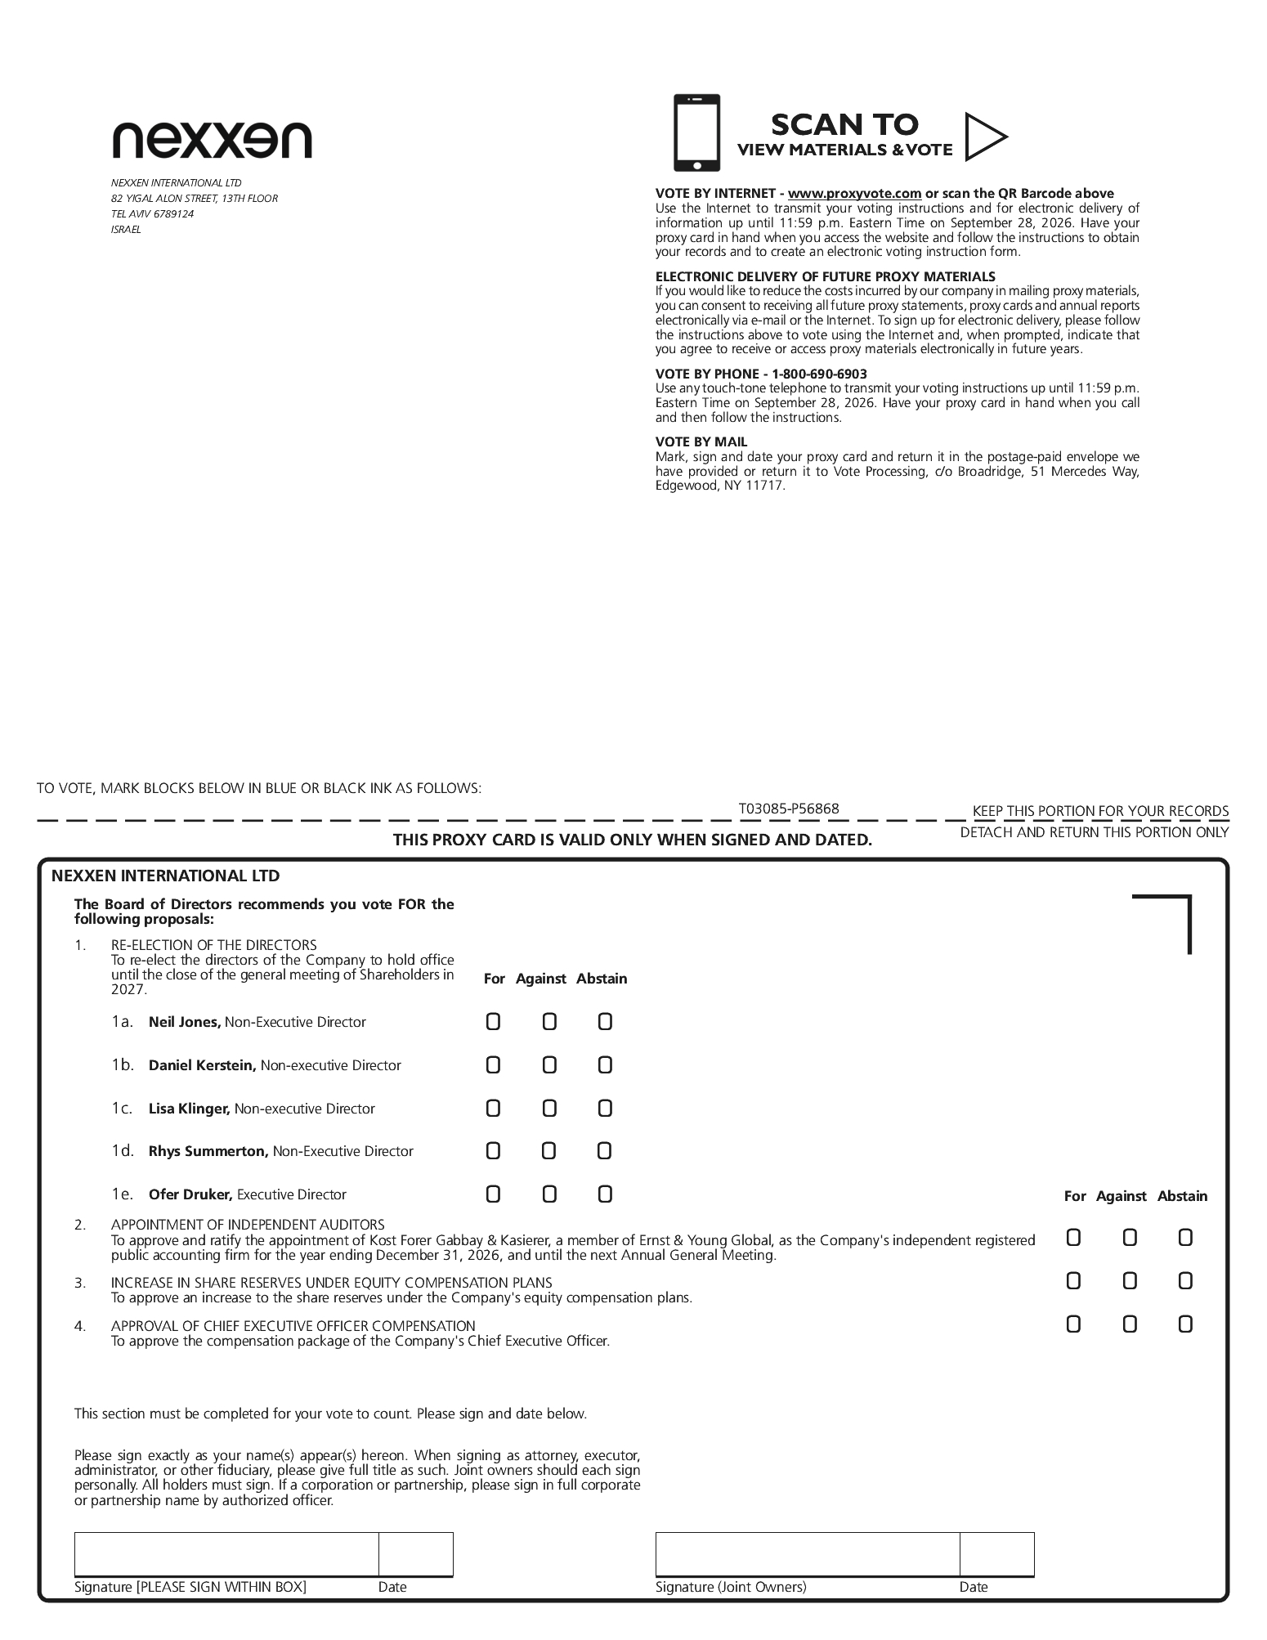

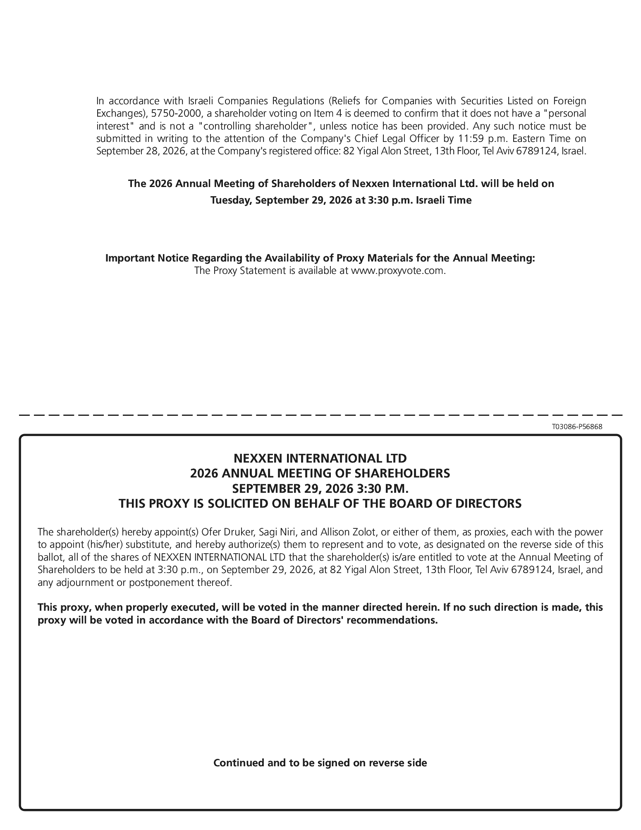

Exhibit 99.3

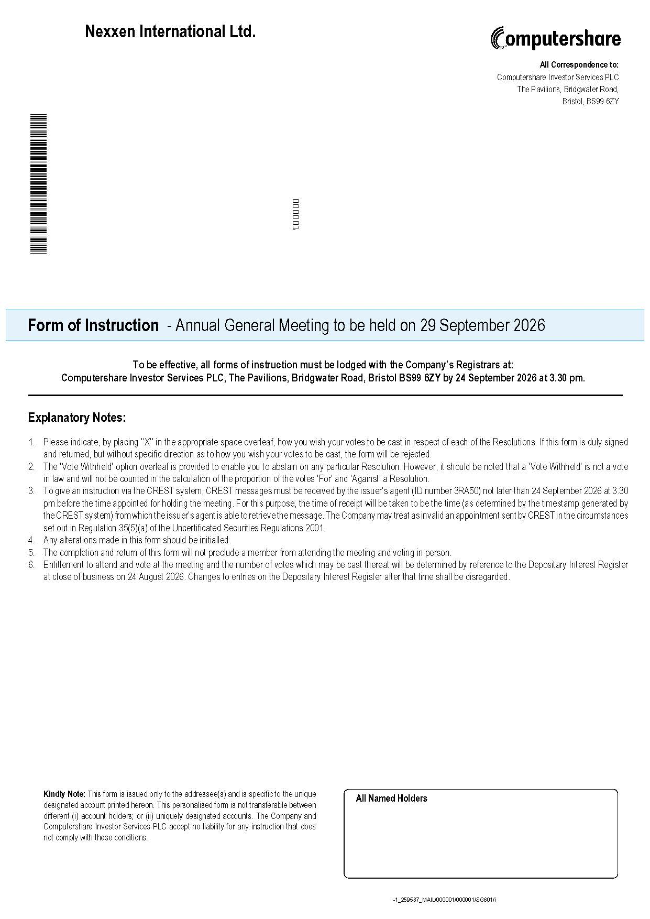
MR A SAMPLE < DESIGNATION> SAMPLE STREET SAMPLE TOWN SAMPLE CITY SAMPLE COUNTY AA11 1AA MR A SAMPLE < Designation> Additional Holder 1 Additional Holder 2 Additional Holder 3 Additional Holder 4 Nexxen International Ltd. Form of Instruction - Annual General Meeting to be held on 29 September 2026 is specific to the unique ot transferable between unts. The Company and ny instruction that does Kindly Note: This form is issued only to the addressee(s) and designated account printed hereon. This personalised form is n different (i) account holders; or (ii) uniquely designated acco Computershare Investor Services PLC accept no liability for a not comply with these conditions. To be effective, all forms of instruction must be lodged with the Company’s Registrars at: Computershare Investor Services PLC, The Pavilions, Bridgwater Road, Bristol BS99 6ZY by 24 September 2026 at 3.30 pm. Explanatory Notes: Please indicate, by placing ‘’X’’ in the appropriate space overleaf, how you wish your votes to be cast in respect of each of the Resolutions. If this form is duly signed and returned, but without specific direction as to how you wish your votes to be cast, the form will be rejected. The ‘Vote Withheld’ option overleaf is provided to enable you to abstain on any particular Resolution. However, it should be noted that a ‘Vote Withheld’ is not a vote in law and will not be counted in the calculation of the proportion of the votes ‘For’ and ‘Against’ a Resolution. To give an instruction via the CREST system, CREST messages must be received by the issuer’s agent (ID number 3RA50) not later than 24 September 2026 at 3.30 pm before the time appointed for holding the meeting. For this purpose, the time of receipt will be taken to be the time (as determined by the timestamp generated by the CREST system) from which the issuer’s agent is able to retrieve the message. The Company may treat as invalid an appointment sent by CREST in the circumstances set out in Regulation 35(5)(a) of the Uncertificated Securities Regulations 2001. Any alterations made in this form should be initialled. The completion and return of this form will not preclude a member from attending the meeting and voting in person. Entitlement to attend and vote at the meeting and the number of votes which may be cast thereat will be determined by reference to the Depositary Interest Register at close of business on 24 August 2026. Changes to entries on the Depositary Interest Register after that time shall be disregarded. All Correspondence to: Computershare Investor Services PLC The Pavilions, Bridgwater Road, Bristol, BS99 6ZY -1_259392_MAIL/000001/000001/SG601/i *00000101010000* 000001

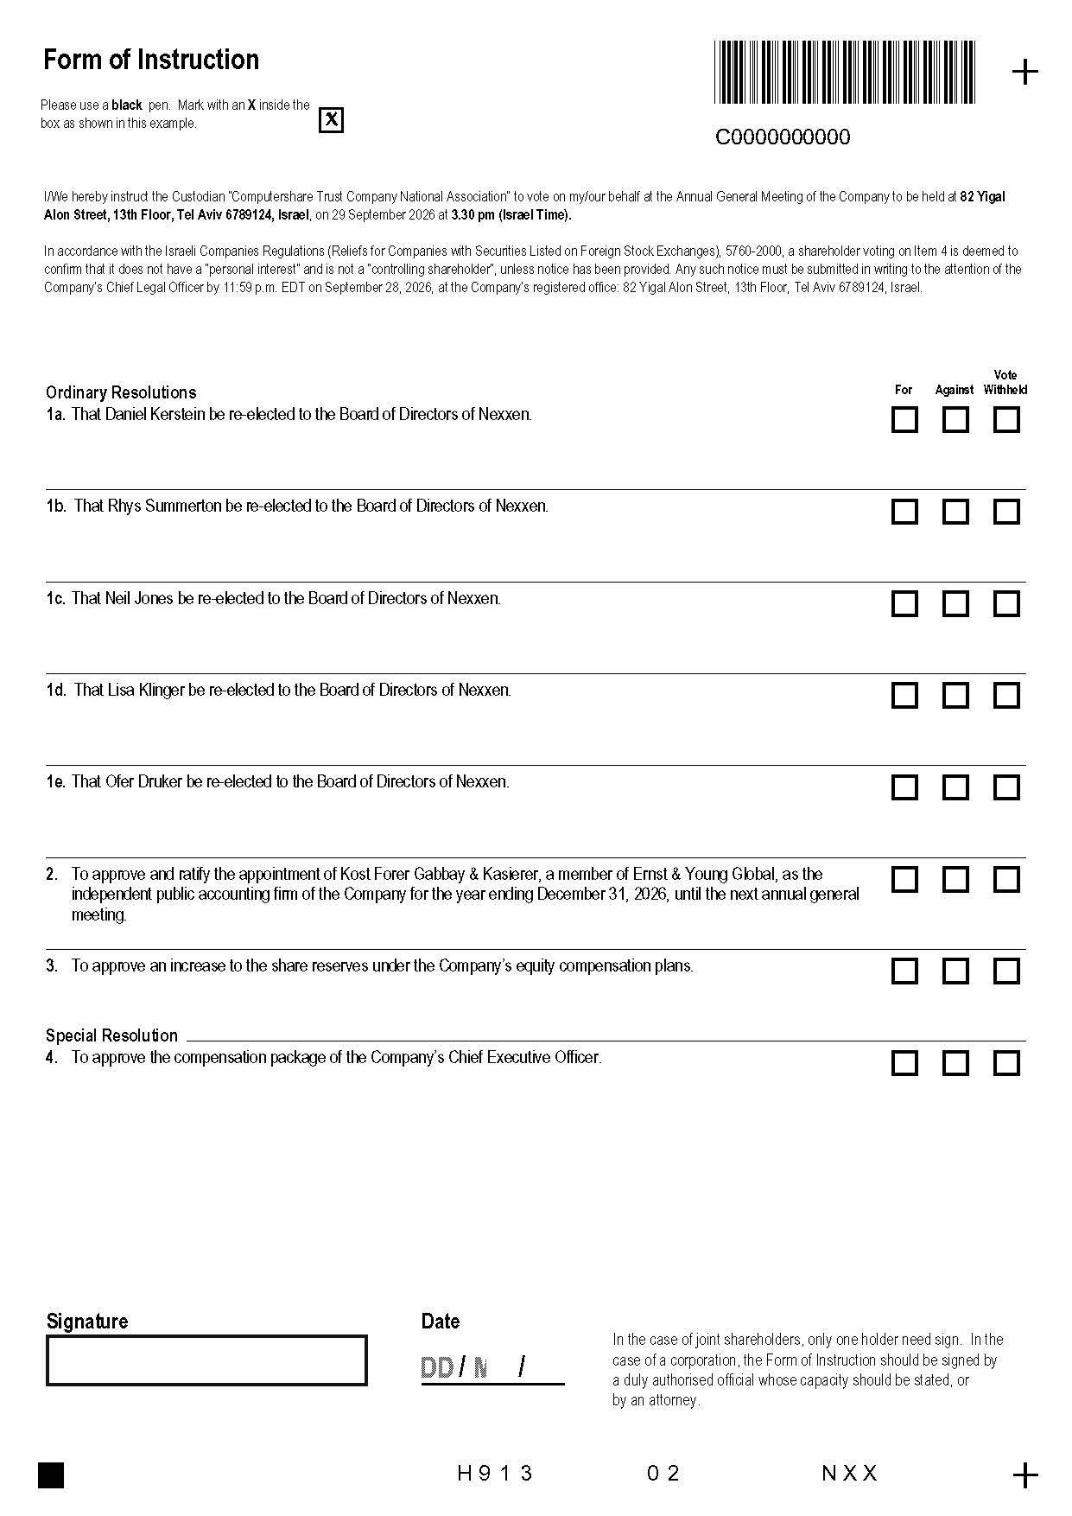
Form of Instruction Please use a black pen. Mark with an X inside the box as shown in this example. I/We hereby instruct the Custodian “Computershare Trust Company National Association” to vote on my/our behalf at the Annual General Meeting of the Company to be held at 82 Yigal Alon Street, 13th Floor, Tel Aviv 6789124, Israel, on 29 September 2026 at 3.30 pm (Israel Time). In accordance with the Israeli Companies Regulations (Reliefs for Companies with Securities Listed on Foreign Stock Exchanges), 5760-2000, a shareholder voting on Item 4 is deemed to confirm that it does not have a “personal interest” and is not a “controlling shareholder”, unless notice has been provided. Any such notice must be submitted in writing to the attention of the Company’s Chief Legal Officer by 11:59 p.m. EDT on September 28, 2026, at the Company’s registered office: 82 Yigal Alon Street, 13th Floor, Tel Aviv 6789124, Israel. Signature Date In the case of joint shareholders, only one holder need sign. In the case of a corporation, the Form of Instruction should be signed by a duly authorised official whose capacity should be stated, or by an attorney.  C0000000000 Vote For Against Withheld Ordinary Resolutions 1a. That Daniel Kerstein be re-elected to the Board of Directors of Nexxen. 1b. That Rhys Summerton be re-elected to the Board of Directors of Nexxen. 1c. That Neil Jones be re-elected to the Board of Directors of Nexxen. 1d. That Lisa Klinger be re-elected to the Board of Directors of Nexxen. 1e. That Ofer Druker be re-elected to the Board of Directors of Nexxen. To approve and ratify the appointment of Kost Forer Gabbay & Kasierer, a member of Ernst & Young Global, as the independent public accounting firm of the Company for the year ending December 31, 2026, until the next annual general meeting. To approve an increase to the share reserves under the Company’s equity compensation plans. Special Resolution To approve the compensation package of the Company’s Chief Executive Officer. H 9 1 3 0 2 N X X

